**// pascal pyramid.**

#include<stdio.h>

#include<conio.h>

void main()

{

int r,c,nr,n,space;

printf("Enter a number for pascal's triangle:"); scanf("%d",&nr);

for(r=0;r<nr;r++)

{

for(space=0;space<(nr-r);space++)

{

printf(" ");

}

n=1;

for(c=0;c<=r;c++)

{

printf(" %d",n);

n=n*(r-c)/(c+1);

}

printf(" \n");

}

getch();

}

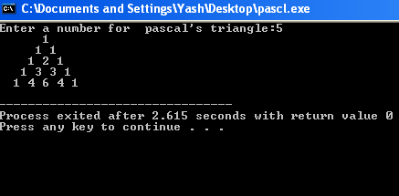

**//print table**

#include<stdio.h>

int main()

{

int n,m,i;

printf("enter the number\n");

scanf("%d",&n);

printf("enter multiples\n");

scanf("%d",&m);

for(i=1;i<=m;i++)

printf("%d\n",n*i);

}

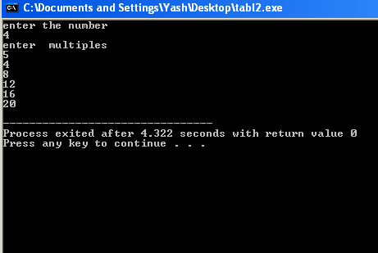



**// 1+½+⅓+¼+......+1/n . Take n as input from the user.**

#include<stdio.h>

int main()

{

int n;

float sum=0.0,i;

printf("sum of series : 1/n \n enter the number of terms\n");

scanf("%d",&n);

for(i=1;i<=n;i++)

sum+=(1/i);

printf("sum of %d terms = %.2f",n,sum);

}

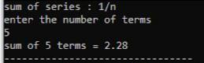

**//outputs the number of zero’s and one’s in its binary equivalent.**

#include<stdio.h>

#include<math.h> int main()

{

int B=0,D=0,c=0,i,f=0; printf("enter decimal number\n");

scanf("%d",&D);

c=D;

for(i=0;;i++)

{if(pow(2,i)>=D){

if(pow(2,i)==D)

{f=1;

B=pow(10,i);

break;

}

else

{i--;

break;

}

}

}

if(f==0)

{for(i;i>=0;i--)

{

if(pow(2,i)<=c)

{

B=B+pow(10,i);

if(pow(2,i)==c)

{

break;

}

else

{

c=c-pow(2,i);

}

}}} c=0;

for(B;B>0;B=B/10)

{

if(B%10==0)

c++;

}

printf("number of 0s in binary equivalent = %d",c);

}

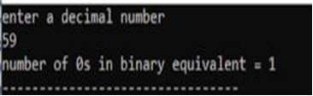

**// Display the following patterns. Take the number n as input from the user.**

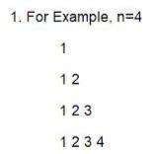

#include<stdio.h>

int main()

{

void pattern(int);

int n,i;

printf("enter a number\n");

scanf("%d",&n);

for(i=1;i<=n;i++)

{

pattern(i);

printf("\n");

}

}

void pattern(int n)

{

if(n==0)

return ;

else

{

pattern(n-1);

printf("%d",n);

}

}

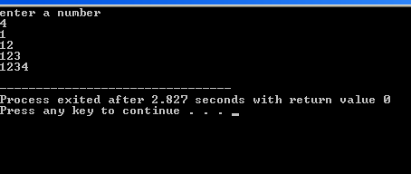

**//draw following figure**

#include<stdio.h>

int main()

{

void print_patt(int,int);

int i,n,f=0;

printf("enter a number\n");

scanf("%d",&n);

for(i=1;i<=n;i++)

{

print_patt(1,i);

printf("\n");

}

for(i=0;i<n-1;i++)

{

print_patt(1,n-1-i);

printf("\n");

}

return 1;

}

void print_patt(int c,int n)

{

if(c<n)

{

printf("%d",c);

print_patt(c+1,n);

}

else

{

printf("%d",c);

return;

}

}

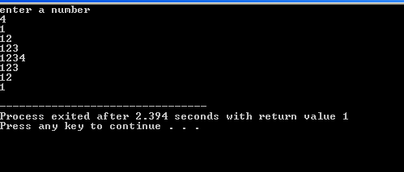

**//draw pattern**

#include<stdio.h>

int main()

{

int n,i,j,c=1;

scanf("%d",&n);

printf("\n");

for(i=0;i<=n-1;i++)

{

for(j=i+1;j>=1;j--)

printf("%d ",j);

for(j=2*(n-i)-3;j>=1;j--)

printf(" ");

for(j=((i!=n-1)?1:2);j<=i+1;j++)

printf("%d ",j);

printf("\n");

}

for(i=n-1;i>=1;i--,c++)

{

for(j=i;j>=1;j--)

printf("%d ",j);

for(j=1;j<=2*c-1;j++)

printf(" ");

for(j=1;j<=i;j++)

printf("%d ",j);

printf("\n");

}

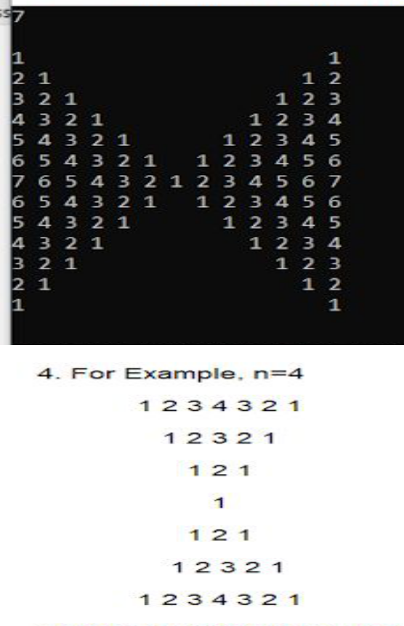

#include<stdio.h>

int main()

{

void print_patt(int,int,int);

int j,i,n;

scanf("%d",&n);

for(i=0;i<n-1;i++)

{

for(j=0;j<i;j++)

printf(" ");

print_patt(1,n-i,0);

printf("\n");

}

for(i=1;i<=n;i++)

{

for(j=1;j<=n-i;j++)

printf(" ");

print_patt(1,i,0);

printf("\n");

}

}

void print_patt(int c,int n,int f)

{

if(c==0)

return;

if(f==0)

{

if(c<n)

{

printf("%d ",c);

print_patt(c+1,n,0);

}

else

{

printf("%d ",c);

print_patt(c-1,n,1);

}

}

else

{

if(c>1)

{

printf("%d ",c);

print_patt(c-1,n,1);

}

else

{printf("%d ",c);

return;}

}

}

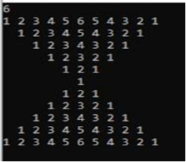

**// find the result for nPr and nCr, take n and r as user input.**

#include<stdio.h>

int main()

{

int fact(int);

int n,r; float ans;

printf("enter a choice\n1. Permutation\n2. Combination\n");

scanf("%d",&n);

switch(n)

{

case 1:

printf("enter the values of n and r respectively\n");

scanf("%d%d",&n,&r);

ans=(float)(fact(n)/fact(n-r));

printf("answer = %.2f",ans);

break;

case 2:

printf("enter the values of n and r respectively\n");

scanf("%d%d",&n,&r);

ans=(float)(fact(n)/(fact(n-r)*fact(r)));

printf("answer = %.2f",ans);

break;

default:

printf("wrong choice");

}

}

int fact(int n)

{

if(n==1||n==0)

return 1;

else

return n*fact(n-1);

}

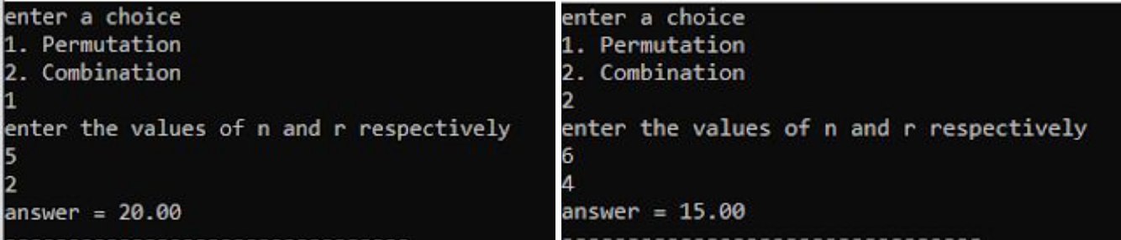

// **a number as input and outputs the product of its individual digits.**

#include<stdio.h>

int main()

{

int num,ans=1; printf("enter a number\n"); scanf("%d",&num); for(num;num>0;num/=10)

{

if((num%10)==0)

{

ans=0;

break;

}

else

ans*=(num%10);

}

printf("multiplication of individual digits = %d",ans);}

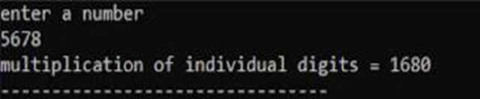

//**Wap that take number as input and gives two output namely the sum of even digits and sum of odd digits of the number.**

#include<stdio.h>

int main()

{

int num,e=0,o=0; printf("enter a number\n"); scanf("%d",&num); for(num;num>0;num/=10)

{

if((num%10)%2==0)

e+=(num%10);

else

o+=(num%10);

}

printf("the sum of even digits = %d\nthe sum of odd digits = %d",e,o);

}

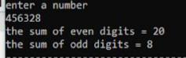

//**145=1!+4!+5!=1+24+120=145**

**//Hence, wap to find such numbers between 1 to n of this**

#include<stdio.h>

int main()

{

int fact(int); int i,n,j,s=0;

printf("enter the last number of the range\n"); scanf("%d",&n);

for(i=10;i<=n;i++)

{

for(j=i;j>0;j/=10)

{

s=s+fact(j%10);

}

if(s==i)

printf("%d\n",i);

s=0;

}

}

int fact(int n) {

if(n==0||n==1)

return 1;

else

return (n*fact(n-1));

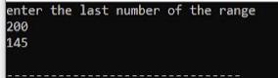}

**//b) x - x2/3! + x3/5! - x4/7! +.....+ xn/(2n-1)!**

#include<stdio.h>

#include<math.h>

int main()

{

int fact(int); int i,f,p; float sum,x,n;

printf("enter the number of terms and the value of x respectively for the series: x-(x^2/3!)+(x^3/5!).......(x^n/(2n-1)!)\n ");

scanf("%f%f",&n,&x);

sum=x;

for(i=2;i<=n;i++)

{

f=fact(2*i-1); p=pow(x,i); if(i%2==0)

sum=sum-(float)p/(float)f;

else

sum=sum+(float)p/(float)f;

}

printf("the sum = %.2f",sum);

}

int fact(int n)

{

int f=1,i;

for(i=2;i<=n;i++)

f*=i;

return f;

}

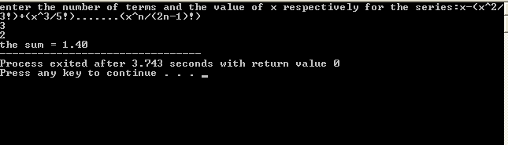

**Print the following series:**

1. **(2) + (2+4) + (2+4+6) +…….+ (2+4+6+2n)**
2. #include<stdio.h>

#include<conio.h> void main()

{

int n,j,i,m,k=2;

printf("Enter a number: ");

scanf("%d",&n);

for(i=1;i<=n;i++)

{

k=2;

printf("(");

for(j=1;j<=i;j++)

{

printf("%d",k);

k+=2;

if(j==i) //for not putting + when k is last term in()

printf("");

else

printf("+");

}

printf(")");

if(i==n) //for not putting + after nth term of series

printf("");

else

printf("+");

}

getch();

}

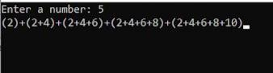

**(12) + (12+32) + (12+32+52) + (12+32+52+72)+.......+(12+32+...+(2n-1)2)** #include<stdio.h>

#include<conio.h> void main()

{

int n,j,i,m,k=1;

printf("Enter a number: ");

scanf("%d",&n);

for(i=1;i<=n;i++)

{

k=1;

printf("(");

for(j=1;j<=i;j++)

{

printf("%d^2 ",k);

k+=2;

if(j==i) //for not putting + when k is last term in()

printf("");

else

printf("+");

}

printf(") ");

if(i==n) //for not putting + after nth term of series

printf("");

else

printf("+");

}

getch();

}

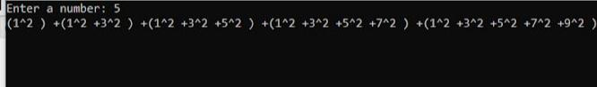

**//Wap to input month number and year and print the calendar for the given month.** #include<stdio.h>

#include<stdlib.h> int main()

{

int dif(int,int,int,int,int,int); int day(int,int,int); void cal(int,int);

int m1,y1;

printf("enter the month and year respectively\n");

scanf("%d%d",&m1,&y1);

cal(m1,y1);

}

int dif(int d1,int m1,int y1,int d2,int m2,int y2)

{

int a[12]={31,28,31,30,31,30,31,31,30,31,30,31}; //number of days in each month int f,s,t,final,temp,i,sum=0,condition;

if(y1<y2) //y1 should always be the smaller year

{

f=(11-m1+1)*30+(31-d1);

date of the same year

for(i=m1-1;i<=10;i++)

{

{

sum=sum+a[i]-30; //calculating number of extra days i.e when number of days

}

f+=sum; //adding extra days

sum=0;

s=y2-(y1+1); //calculating no. of years between given years;

s*=365; //adding 365 days for each year

condition=(m2>=2)?y2+1:y2; //if the ending year includes the month of feb we check the

ending year also if it is a leap year

for(i=(m1<=2)?y1:y1+1;i<condition;i++) //same for the starting year

{

if(i%400==0)

{

s++;

//if leap year, we add an extra day

}

else if(i%100!=0)

{

if(i%4==0)

s++;

}

}

t=(m2-1)*30+(d2-1);

//calculating the no. of days fron the first day of the ending year to

the given date

for(i=0;i<=m2-1-1;i++)

{

sum=sum+a[i]-30;

//no. of extra days

}

t+=sum;

final=f+s+t;

//printf("%d",final);

//adding no. ofextra days

//finally adding all the calculated days

}

else if(y1==y2)

{

//if starting and endng year is same

f=(m2-m1)*30+(d2-d1);

for(i=m1-1;i<=m2-1-1;i++)

{

sum=sum+a[i]-30;

}

f+=sum;

return f;

}

return final;

}

int day(int d,int m,int y)

{

int diff=0,d1=1,m1=1,y1=1990;

diff=dif(d1,m1,y1,d,m,y);

diff++;

diff=diff%7;

switch(diff)

{

case 1:

printf("%s","Monday\n");

break;

case 2:

printf("%s","Tuesday\n");

break;

case 3:

printf("%s","Wednesday\n");

break;

case 4:

printf("%s","Thursday\n");

break;

case 5:

printf("%s","Friday\n");

break;

case 6:

printf("%s","Saturday\n");

break;

case 0:

printf("%s","Sunday\n");

}

return diff;

}

void cal(int m,int y)

{

int a[12]={31,28,31,30,31,30,31,31,30,31,30,31};

int i;

if(m==2)

{

if(y%400==0)

{

a[1]++; //if leap year, we add an extra day in feb

}

else if(y%100!=0)

{

if(y%4==0)

a[1]++;

}

}

for(i=1;i<=a[m-1];i++)

{

printf("%d : ",i);

day(i,m,y);

}

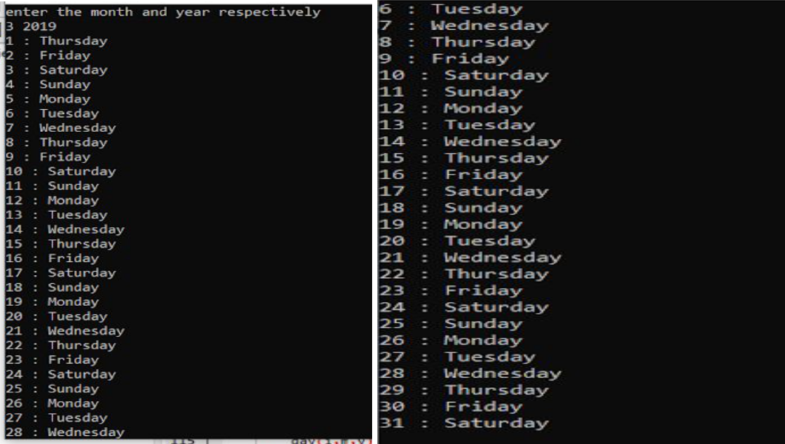

**//Wap to add the number of days or number of months in a given date.** #include<stdio.h>

#include<stdlib.h> int main()

{

void add(int,int,int,int,int); int d1,m1,y1,a; printf("enter the date\n");

scanf("%d%d%d",&d1,&m1,&y1);

printf("what do you want to add?\n1) days\n2)months\n");

scanf("%d",&a);

switch(a)

{

case 1:

printf("enter value\n");

scanf("%d",&a);

add(d1,m1,y1,a,0);

break;

case 2:

printf("enter value\n");

scanf("%d",&a);

add(d1,m1,y1,0,a);

break;

default:

printf("wrong choice!");

}

}

void add(int d,int m,int y,int ad,int am)

{

int a[12]={31,28,31,30,31,30,31,31,30,31,30,31},i,sum=0,j;

if(am==0)

{

while(ad>0)

{

if(d<a[m-1])

{

d++;

ad--;

}

else

{

d=1;

m++;

ad--;

if(m>12)

{

m=1;

y++;

}

}

}

}

else

{

m=m+am;

if(m>12)

{

m=m-12;

y++;

}

}

printf("%d/%d/%d",d,m,y);

}

